**CSCI 5709 – ADVANCED WEB SERVICES**

**Assignment 1**

**Instructor:** Gabriella Mosquera

Group - 07

|  |  |
| --- | --- |
| **Name** | **Banner ID** |
| Harshil Shah | B00919966 |

**‘ClassMate’: School at your fingertips!**

# A1.5 User Experience and Task Flow

## User Management [Harshil Shah]

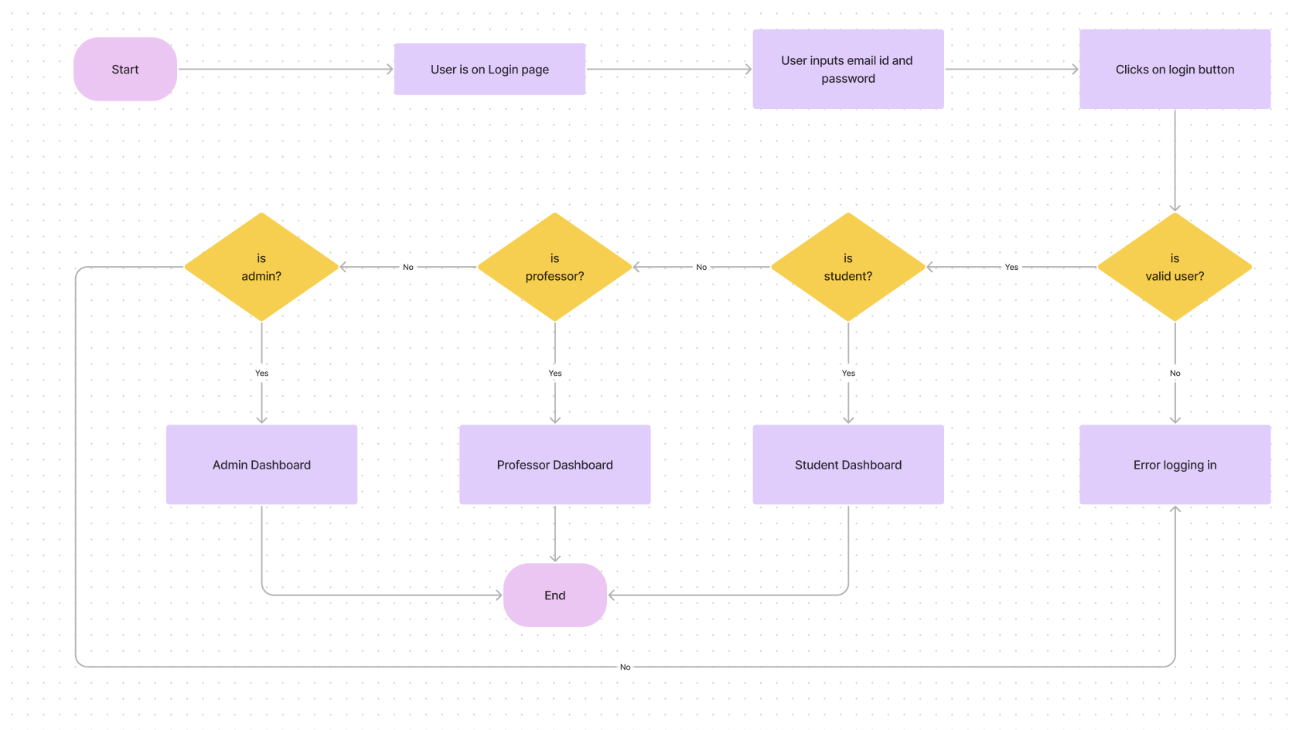

Figure 1: Task flow for login

Figure 2: Task Flow for registration

# A1.6 Lo-Fidelity Prototype

## User Management [Harshil Shah]

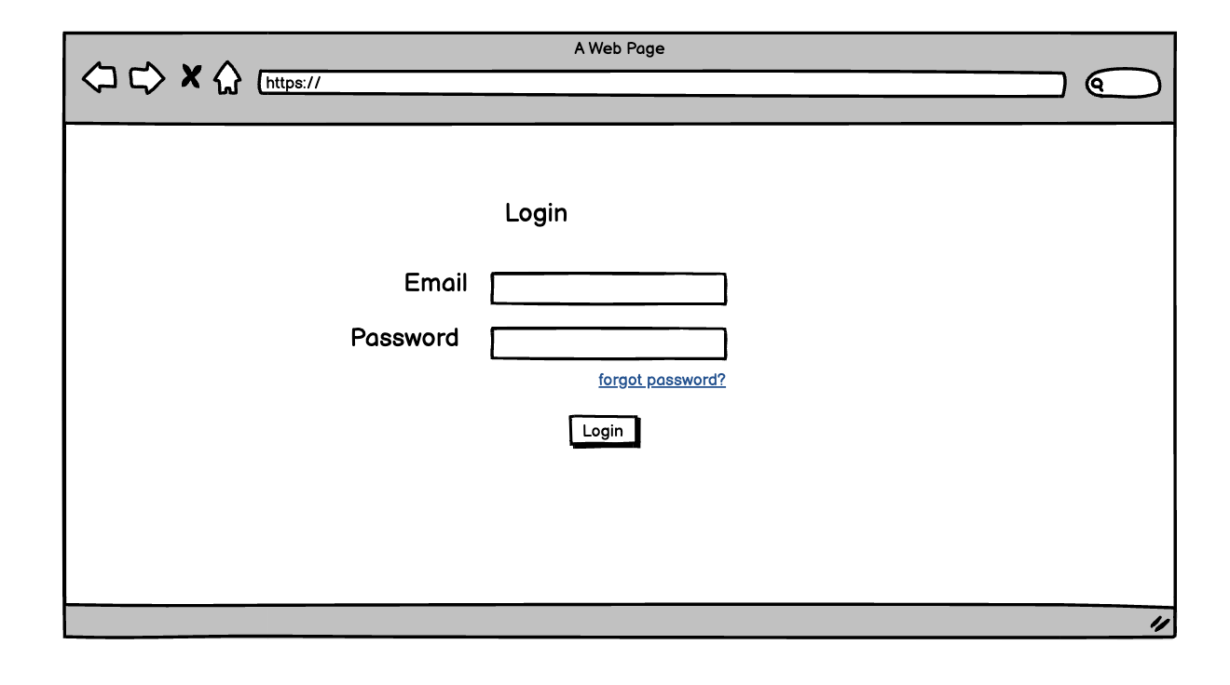

Figure 3: Unified Login Screen

Figure 4: Empty Username password Alert

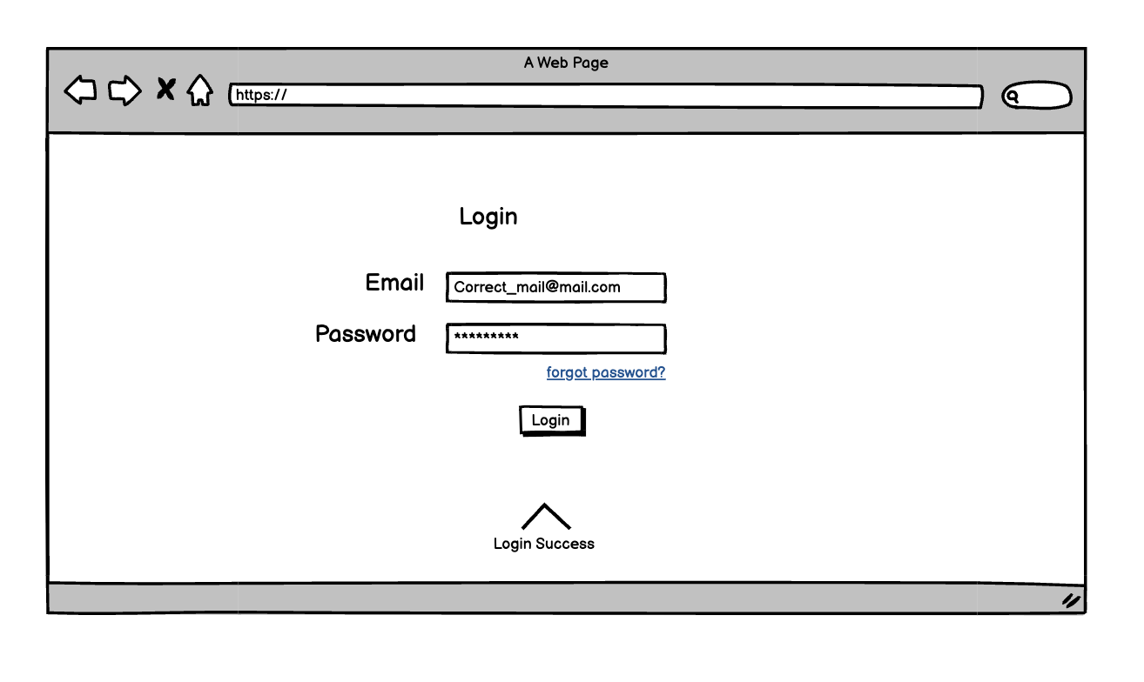

Figure 5: Successful Login

Figure 6: Wrong Username/Password Alert

Figure 7: Create Professor/Student from admin panel.

Figure 8: Password Validation failed.

Figure 9: User Creation success

Figure 10: User Listing, Search - Filter & Deletion Window

Figure 11: Alert While deleting.

Figure 12: Deletion Success message

Figure : W3C Validation

**References:**

1. “Flowchart maker & online diagram software,” *Diagrams.net.* [Online]. Available: <https://app.diagrams.net/>. [Accessed: May 27, 2023]
2. “Balsamiq cloud,” *Balsamiq.cloud*. [Online]. Available: <https://balsamiq.cloud/> . [Accessed: May 18, 2023]
3. “The Collaborative Interface Design Tool.,” *Figma*, <https://www.figma.com/> [Accessed: May 27, 2023].